**Smarthinking Tutor Response Form**

Your tutor has written overview comments about your essay in the form below. Your tutor has also embedded comments **[in bold and in brackets]** within your essay. Thank you for choosing Smarthinking to help you improve your writing!

Hello, James! I’m Cathy H., and I look forward to working with you on this **Essay Center Review** to improve your writing today. Let's get started!

**\*Writing Strength:**   
  
You get right to the point in your letter; by the end of the first two sentences, I know what to expect from what you’ll say.

**\*James 10173865 has requested that you respond to the Organization:**   

I thought the organization of this worked very well. You started with a broad discussion of the obesity issue in children, then narrowed it down to the discussion of sugar in drinks and how much sugar kids are consuming in school. You ended with a good call to action that recapped your argument in a clear and concise way.

**\*James 10173865 has requested that you respond to the Transitions:**   

 I also thought your paragraphs worked well and that you broke for a new paragraph at appropriate places. You were cognizant of when your discussion changed direction or began to shift. The transitions were easy to follow.

**Word Choice** 

The one word choice that caused me to stumble, as a reader, was right in your main idea:

* We need to take immediate actions to remove flavored from the lunch program and find a healthier alternative.

You’re missing a word after “flavored.” As I read on, I began to see that you were discussing flavored milk. Make sure that you make this clear in your main idea. The main idea is important as it acts as a road map for the rest of the paper. If the main idea is stated smoothly, the reader will have no trouble going on to understand the rest of your argument.      
  
  
  
**Summary of Next Steps:**

* Make sure your wording is clear in the main idea. Identify exactly what needs to be removed.
* Proofread for any grammatical errors.

Thank you for submitting your essay for a review, James. I enjoyed helping you with this step in the revision process. Have a good day! ~Cathy H.

You can find more information about writing, grammar, and usage in the [Smarthinking Writer's Handbook](http://services.smarthinking.com/static/Document_Library/docs/writeman/contents.cfm).

_________________________________________________________________________________

Please look for comments **[in bold and in brackets]** in your essay below.  
Thank you for submitting your work to Smarthinking! We hope to see you again soon.

Mrs. Conner

Principal

Eisenhower Elementary School

277 Rondonovan Dr.

Santa Clara, CA 95051

Dear Mrs. Conner:

As you are already aware, childhood obesity is a nationwide epidemic that affects millions of children throughout our country. One of the root-cause of childhood obesity is public school lunch program, and it's affecting our students here at Eisenhower Elementary School. **[“Root-cause” is an awkward word choice; try “root causes.”]**  There have been numerous studies conducted by Centers for Disease Control to understand the problem, and Congress has even attempted to solve this epidemic by introducing several fundamental changes to the lunch program. The proposed solutions have made no significant impact, and all the students are still affected each day. In 2010 the Journal of School Health, the author Ji Li revealed some startling statistics that children attending a public school that participates in National Public Lunch Program have a 4.5% probability of being overweight. Furthermore, children have higher BMI than those attending private school. (Journal of School Health, 2010) We need change, and you can help to make a difference. A simple switch in the lunch menu can have a significant positive impact on our kid's health. We need to take immediate actions to remove flavored from the lunch program and find a healthier alternative. **[What is flavored and what needs to be removed?]**

Any attempt to solve childhood obesity is a monumental task, and we're undoubtedly not trying to resolve this issue here. However, what we are attempting is to make a small change that will have a lasting impact on our kid's health. A program like Healthy Hunger-Free Kids Act strives to provide healthy and balanced meals. The daily lunch program incorporates whole grain meals, fruits, and choice of beverages. As described in the U.S. News article in 2016, part of the original program requires that kids are offered two types of drinks: fat-free milk and 1 percent milk. And flavored milk is also permitted as long as it's fat-free. (U.S. News 2016) This mandate was put in place to provide options for our kids. The students will have an option of choosing a fat-free or 1 percent flavored milk. What is not apparent is the content of the flavored milk which can contain up to 20 grams of sugar. To put this number into perspective, a single can of Coca-Cola contains 39 grams of sugar. **[So far your organization is logical and easy to follow.]** If a student consumes all the available meals at school, they would be drinking roughly 40 grams of sugar per day. That is ten teaspoons of sugar. The most logical way to approach this issue is by eliminating the flavored milk from the menu. Although this may seem like a stopgap measure, it is the most feasible way to handle this problem until a permanent solution can be put in place.

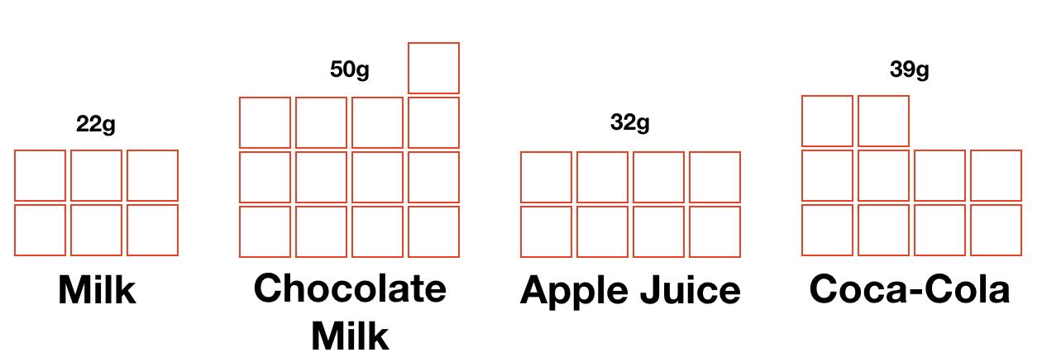

In a district in Georgia, concerned parents and PTA decided to overhaul their lunch program to provide healthier meals for their students. The new program introduced whole-grain foods and fresh fruits as an alternative which increased fruit and veggie consumption by 40%. (Time 2012) In the same TIME magazine article, the author also states "schools also eliminated sugary beverages from their vending machines and replaced them with water and 100% juice drinks. (Time, 2012)” Although this didn't eliminate all the sugary beverages from the school campus, it did restrict access by removing sodas from the vending machines.

Some may argue that we should let the government manage the lunch program. But the truth is it hasn't worked. **[Your transitions are also working well; this is a good place to break for a new paragraph as you discuss the government trying to manage the lunch program.]** We currently do have a national lunch program and the program is designed to provide healthy and balanced meals for our kids at school, but it is politicized and doesn't provide the necessary restriction to protect the kids. The meal guideline recommends availability of different types of milk to school but as mentioned in the U.S. News article, "powerful dairy lobby to mandate higher consumption of milk in schools and to promote flavored milk as a way to do so, which of course would add more sugar into school meals. (U.S. News A World Report 2016)"

It is clear that this issue affects us at Eisenhower Elementary School. Childhood obesity is on the rise, and it is critical that we take immediate steps to address the problems. In an article published by U.S. News World Report, the writer Ann Cooper reports "the Centers for Disease Control and Prevention has reported that 17 to 30 percent of children ages 2 to 19 are overweight or obese. (U.S. News A World Report 2016)" Reducing the amount sugar intake and eliminating excess calories can drastically help to prevent childhood obesity.

It is time to step in and make the right decision that will help shape the lives of all the students at Eisenhower Elementary School. The removal of sugar-packed beverages from the lunch menu will not only help all the students, but it will start the beginning of their new healthy lifestyle. **[This is a good wrap up of your argument.]**

Sincerely,

James J. Kim

References

Auge Karen (2009) The Denver Post [Photograph]  
<http://www.denverpost.com/2009/11/29/colorado-schools-face-cartons-of-controversy-over-milk/>

Cooper Ann (2016) U.S. News  
<https://health.usnews.com/health-news/blogs/eat-run/articles/2016-03-25/snack-crack-our-childrens-addiction-to-sugar>

Julie Kelly, Jeff Stier (2015) *The School Lunch Program With an Unappetizing Report Card* <https://search-proquest-com.ezproxy1.lib.asu.edu/docview/1689552371?accountid=4485&rfr_id=info:xri%2Fsid:primo>

Keith-Thomas Ayoob. Childhood Obesity. August 2011, 7(4): 271-273.   
<https://doi-org.ezproxy1.lib.asu.edu/10.1089/chi.2011.0400.edit>

Li Ji, Ph.D., Hooker Neil H, Ph.D. (2010) Childhood Obesity and Schools: Evidence From the National Survey of Children's Health  
<http://onlinelibrary.wiley.com.ezproxy1.lib.asu.edu/doi/10.1111/j.1746-1561.2009.00471.x/full>

Robinson Thomas N., MD, MPH ( 2005) Preventing childhood obesity: A solution-oriented research paradigm  
<http://www.sciencedirect.com.ezproxy1.lib.asu.edu/science/article/pii/S0749379704003101>

Sifferlan Alexandra (2012) Time   
<http://healthland.time.com/2012/12/31/more-food-for-hungry-students-usda-tweaks-school-meals/>